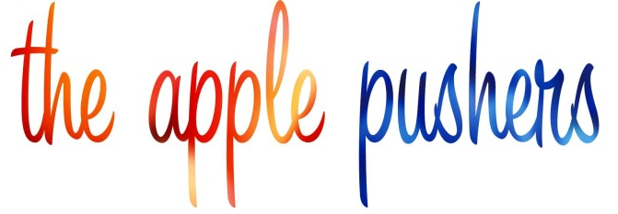

THE APPLE PUSHERS NATIONAL ROLL-OUT IN ALL MEDIA
Film Chronicles Immigrant Entrepreneurs in Action in New York’s Food Deserts
National Public Television Premiere on May 6 * Available Online
Five city theatrical screenings on Earth Day with Whole Foods Market

New York – April 2012 – The Apple Pushers, a new documentary that tells the inspiring stories of immigrant streetcart vendors who sell fruits and vegetables in the “food deserts” of New York City, is launching its national distribution in the coming weeks. Directed by award-winning filmmaker Mary Mazzio and underwritten by the Laurie M. Tisch Illumination Fund, the film will be nationally broadcast on public television stations, available on-line and for events distributed by Oscilloscope Laboratories, and be theatrically screened in five cities on Earth Day as the launch of the Do Something Reel Film Festival from Whole Foods Market.

National Broadcast Premiere: On Sunday, May 6, The Apple Pushers will have its national broadcast premiere on the WORLD channel (formerly known as PBS World). WORLD is produced and distributed by WGBH Boston, WNET New York Public Media, and American Public Television (APT) in association with the Public Broadcasting Service (PBS) and the National Educational Telecommunications Association (NETA). WORLD is available in 63 markets on 142 public television stations, representing more than 52% of U.S. households, and 12 of the top 20 markets, including New York, Los Angeles, Philadelphia, Dallas, Boston and Atlanta. Check local listings.

Five City Screenings: The Do Something Reel Film Festival from Whole Foods Market kicks off on April 22, with theatrical screenings of The Apple Pushers followed by a panel discussion in Austin with the film’s director, Mary Mazzio and executive producer, Laurie Tisch, moderated by television star Debi Mazar (“Entourage” and “Extra Virgin”) with introductory remarks by Academy Award Nominee, Edward Norton. Additionally, theaters in Boston, Detroit, Pittsburgh and San Francisco will host simultaneous screenings of the film and the panel discussion which will also be live streamed on the web.

Online Availability: Later in the Spring, The Apple Pushers will be available online, distributed by Oscilloscope Laboratories which has acquired the North American rights to the film. In addition, Oscilloscope is planning a series of special screenings and engagements in major cities. JOSH – OSCILLOSCOPE HAS ACQUIRED ALL NORTH AMERICAN RIGHTS WITH SOME CARVE-OUTS.

Narrated by Academy Award nominee Edward Norton, The Apple Pushers captures the triumphs and the hardships of immigrants who, under an innovative program, sell fresh produce in food desert neighborhoods where finding a ripe apple is a challenge. Through the lens of their powerful and deeply personal stories, the film examines such hot-button issues as food access, the obesity crisis, immigration, entrepreneurship, and what it really takes to achieve the American dream. "Emotionally, the film packs a wallop..." - Tracie McMillan, The Atlantic

The film is inspired by the NYC Green Cart Initiative, which aims to increase the availability of fresh produce in city neighborhoods by creating opportunities for entrepreneurs to set up micro-businesses. Launched in 2008, the program has become a national model – using mobile vending to reach communities where rates of diabetes, heart disease and obesity are skyrocketing. A unique free-enterprise strategy, this program has launched more than 500 vendors. Catalyzed by the film, other cities are exploring and launching their own mobile-based solutions to bring economic opportunity and fresh produce to communities in need.

Prominent recent screenings: New York as the kick-off for NYC’s Immigrant Heritage Week at the Museum of the Moving Image; Boston, hosted by Henry Louis Gates, Jr. and the W.E.B. Du Bois Institute for African and African American Research of Harvard University, the Boston Foundation and Common Angels; Los Angeles, hosted by LURN - Leadership for Urban Renewal Now; Washington, D.C. hosted by the USDA for federal policy makers. Upcoming screenings: Philadelphia, hosted by the American Diabetes Association.
The Apple Pushers was written and directed by Mary Mazzio. Her previous films include TEN9EIGHT, which tells the stories of inner-city teen entrepreneurs, and A Hero for Daisy, which chronicles the 1976 protest by Yale women athletes that changed American college sports forever.

To view the film’s trailer: http://youtu.be/luABtB53Dzo

For information about the film: www.applepushers.com

For a review DVD, contact Media Relations:
Josh Baran: jcbaran@applepushers.com -- 917-797-1799
Juli-anne Whitney: juliannewhitney@applepushers.com -- 917-741-5674

